Database EvaluatOr Project Proposal

Project Team

|  |  |
| --- | --- |
| Project Proposal | Subject  Database Evaluator Project Proposal |
| Date  17-June-2016 |
| Sector  DBA |
| Author  Changming Wu |

Document history

|  |  |  |  |  |
| --- | --- | --- | --- | --- |
| Version | Date | Author | Changes | Valid from |
| 1.0 | 19-Jul-2016 | Changming Wu | Edit | 19-Jul-2016 |
| 1.1 | 19-Jul-2016 | Changming Wu | Edit | 19-Jul-2016 |
| 1.2 | 19-Jul-2016 | Hardik Kansara, Patrick Cura | Edit | 19-Jul-2016 |
| 1.3 | 19-Jul-2016 | Kwinno Pineda, Patrick Cura | Edit | 19-Jul-2016 |
| 1.4 | 31-Jul-2016 | Kwinno Pineda, Patrick Cura | Edit | 31-Jul-2016 |
| 1.5 | 01-Aug-2016 | Changming Wu | Edit | 01-Aug-2016 |
| 1.6 | 03-Aug-2016 | Changming Wu | Edit | 03-Aug-2016 |
| 1.7 | 12-Aug-2016 | Hardik Kansara | Edit | 12-Aug-2016 |
| 1.8 | 14-Aug-2016 | Hardik Kansara, Kwinno | Edit | 14-Aug-2016 |

Table of Contents

1 Executive Summary 3

2 Project Personnel 4

3 Opportunity Context 4

4 Project Requirements 4

5 Project Analysis 6

6 System Outline 7

7 Approach 9

8 Organization of the Project 9

9 Management 11

10 Plans and Procedures 13

11 Staff 13

12 Deliverables 14

13 Resumes (CVs) 14

14 Relevant Background Information 14

15 Resources 15

16 Team Acceptance 15

17 Appendices 17

1. Executive Summary

Secure and efficient database implementation with suggested best practice is one of the challenges for an organization and as well as for a database administrator.

Identifying details of SQL Server configurations is a time consuming process and lots of manual work for a new database administrator who wants to know the configured parameters values of all SQL Server instances and databases without well maintained inventory.

Sometimes it is very difficult for a database administrator to check and create an inventory of all the database parameters especially for large SQL Server environment. Maintaining the databases accordance to best practice will also become challenging when organisation has so many databases.

With the stated challenges, the group aims to produce a database evaluator that will diagnose and check the basic implementation parameters of SQL Server Instances and Databases. The database evaluator will target all versions of SQL Server starting with SQL Server 2008 and SQL Server 2012. Older versions of SQL server will not be supported. Project will be targeted to finish 04/11/2016. There is no cost included for this project and there is no risk involved with executing a client application on a database system as it will not modify any existing parameters for a database and database system. The project team will be responsible to deliver the final products for this project which are as follows:

1. A website from where a customer can download the client application and upload the database dump files.
2. A client application that will produce a dump file of the client’s database with exiting parameters values only.
3. A database evaluator tool that will generate reports from the dump files uploaded by customers.

It is planned that these dump files will be encrypted for security purposes. The client application is free to download from the product website and profit will be generated instead when customers choose to avail of the database evaluation services.

1. Project Personnel

|  |  |  |
| --- | --- | --- |
| Name | Email | Phone |
| Steve McKinlay | steve.mckinlay@weltec.ac.nz |  |
| Changming Wu | wuchangming729@gmail.com | 0211887191 |
| Hardik Kansara | hardik.kansara2002@gmail.com | 0211811046 |
| Kwinno Pineda | kwenno@yahoo.com | 0212968600 |
| Patrick Cura | patrick_cura1989@yahoo.com | 0212953418 |

1. Opportunity Context

The project team want to attract Small and medium-sized enterprises who has implemented SQL server in their infrastructure and want to know the implementation risk and verify the configuration of databases and SQL Server. The biggest opportunity with this project are first customer can see what parameters are missing with the exiting database implementation. Large number of SQL Server instances auditing is also very easy perform by this tool.

Customer will get the benefit of an audit report to tune their database parameters in well advance to overcome all the security and performance problems. Sometimes it will costly for a small business to hire a professional or a contractor to evaluate their database system because it is time consuming and costly process.

Therefore, this tool is also for a business or a customer who may not be able to hire a full time database administrator to diagnose their database system.

The team are required to provide a project as part of their degree programme where team needs to find a suitable project client, to develop a solution to meet the client’s requirements to fulfil their project.

1. Project Requirements

* Website

Customer can download a client application from website. Installation guide and instruction are available on the website.

The website will allow customer to upload the encrypted files after they have successfully logged in to their account.

* Client Application

A client application is a light weight and small tool which will be executed on a customer database system and gather the exiting configured values for parameters and captures the encrypted files.

The following areas of database from where parameters values will be collected by client application.

* SQL Server Instance

1. Installation

2. Configuration

3. Security

* SQL Server Database

1. Implementation of Database (physical structure)

2. Database Configuration Options

3. Maintenance

4. Security

* Database Simulator

Parameters in encrypted file will be diagnosed with another application called Database Simulator. Database Simulator will check all the parameter against the best practice values and generate the final report.

The final report will display all information about what parameters are not configured and suggest and what will be the parameter values as per suggested best practice.

The customer can download their final report from the website.

The project team’s requirements are 1600 hours of work for each of the project members. The project will be due on the 4nd of November 2016.

1. Project Analysis

The team is composed of a Database Specialist, a Web Developer, a Programmer and a certified Project Manager.

Given that our target market are users of Microsoft SQL Servers, we have a Database Specialist who is experienced in handling and administering Microsoft SQL Servers. With their skills, we are confident that a Database Evaluator and a client application will be produced. With standards.

Project team target Relational database management system (RDBMS) is a Microsoft Product, the Database Evaluator and client application should be built using a Microsoft product as well. In this case, the team’s Programmer has a choice between Visual Basic or C# to create the Windows Form Application. The Programmer has experience in programing so the C# will be used. Since there is a fixed deadline that needs to be met, every moment is important so trying to learn a new language with unfamiliar syntax should be avoided. For the IDE, Visual Studio will be used as it already has some drag and drop tools to make the development of the GUI of the desktop application easier.

Besides the actual Database Evaluation tool, a product website is also needed. The product website from where the tool will be downloaded by the users. There are a lot of available technologies that can be used for web development but because time is of the essence, the chosen ones are PHP, WordPress and MySQL. The team’s Web Developer already has experience in creating websites using the said technologies and this will allow us to develop the website quickly along with the tool. Also, WordPress, being a CMS tool, has a lot of Plugins and Themes that just needs to be imported to use. These plugins will make designing the website much easier. Furthermore, finding resources and references for the said technologies will be easier given that many websites are built from them.

A GitHub will be used as document management application to keep track of the code and documentations. The reason is that it is quite easy to use even for first time users given that there is GitHub Desktop for easy upload.

Dynamic System Development Model Atern (DSDM Atern) development framework will be used as methodology to develop all the products of the project because the time and cost for DSDM Atern are fixed which leaves us to worry about scope only. Another reason to choose DSDM Atern is because it has a large community worldwide with different companies using this agile methodology. Furthermore, DSDM Atern can be used for large and small projects depending on the needs of the project. Using DSDM Atern, risks will be minimized as the project progresses because of its iterative and incremental approach.

1. System Outline

The final products of the project are as follows:

* The client application that will produce a dump file of the client’s database information.
* The client application is a light weight tool which will need to be installed on the customer system. It will connect to the SQL server instance and then execute.
* It will generate the encrypted dump file which contains all the current information of all the configured parameters value of SQL server instance and database.
* Executor have choice to execute the client application either only for SQL Server instance or execute on instance with single database both.
* Executor cannot execute the evaluator on multiple database at a same time.
* The website from where a customer can download the database evaluator and upload the generated dump files.
* A website is used to download client application and upload the dump file.
* A website page also help customer to know the tool installation procedures along with term and conditions agreements between customer and project team.
* The database evaluator tool that will generate final reports from the dump files uploaded by customers.
* The encrypted dump file contains the customer database parameters values only. It is planned that these dump files will be encrypted for security purposes.
* The final report will be generated after executing the database evaluator.

See Data Flow Diagram:

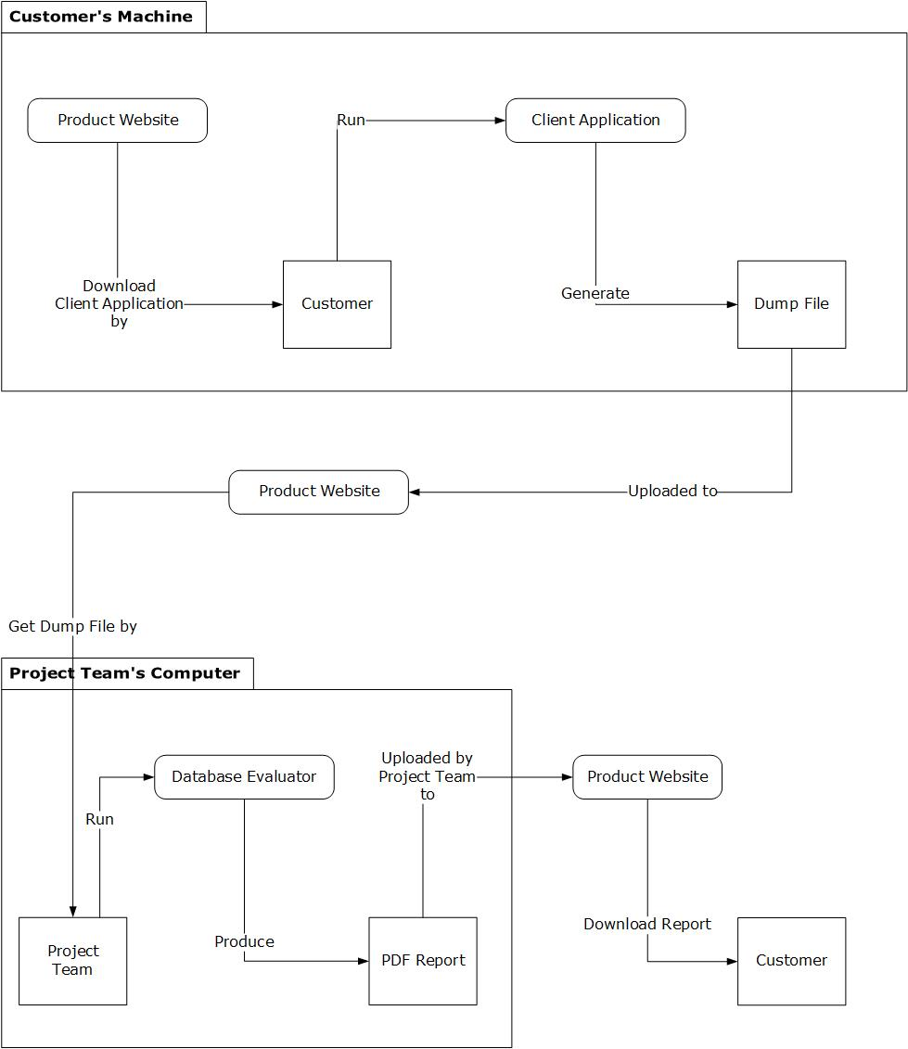

1. Approach

DSDM Atern is an agile development framework, will be used to produce the desired product of this project. DSDM Atern is one of the agile frameworks that companies use due to its features of fixed time and cost. Scope will be the only factor that will change mostly in this project. The Project in a Box has DSDM Atern templates. These will greatly help us in delivering documents and keep us on the right track throughout the project.

The model of the DSDM Atern will be used as the guide in setting the dates, and distributing and prioritizing tasks. DSDM follows a reverse triangle planning. The project requirements must be extensively and carefully planned at the start before proceeding to the next phases. Delivering the deliverables on time without sacrificing the quality is what makes DSDM hard to use but worth it at the end.

1. Organization of the Project

Below is a breakdown of the people involved in project.

* Project Manager, Test Manager
  + Changming Wu
* Database Specialist, Tester
  + Hardik Kansara
* Web Developer, Tester
  + Kwinno Pineda
* C# Developer, Tester
  + - * Patrick Cura
* Project Advisor
  + - * Steve McKinlay

From the details given above, here is a RACI chart that shows which people will be assigned to which tasks:

|  |  |  |  |  |  |
| --- | --- | --- | --- | --- | --- |
| Tasks | Changming Wu | Hardik Kansara | Kwino Pineda | Patrick Cura | Project Advisor |
| 1. Create the Project Specification and Requirements | C | R A | C | C | C |
| 2. Create the Customer Application | I | C | I | R A | C |
| 3. Create the Project Website Application | I | C | R A | C | C |
| 4. Create the Database Evaluator | I | C | I | R A | C |
| 5. Create the Test Plan | R A | C | C | C | C |
| 6. Test the Applications | A | R | R | R | C |
| 7. Database Evaluation Guidelines and the related Query Scripts | I | R A | I | C | C |
| 8. Handle the Project Management Aspects for the team | R A | C | C | C | C |

1. Database Specialist will handle the creation of the project specification and requirements because it is his domain of expertise. He will consult and inform of the team of the scope so as to get a consensus if the team can do it as per their current skills.
2. C# developer will mainly be in charge of creating the customer application (the one to be distributed to customers) and the Database Evaluator. Because database knowledge is needed in getting the needed information from a customer’s computer, the Database Specialist needs to be consulted and asked for help. The other members will be informed of the software development progress.
3. Web Developer will be in charge of creating the website that the customers will be using. He will consult the Database Specialist and C# developer as there might be a chance that their applications will interact in the future. All team members must also be informed of the website development progress.
4. Test Manager will handle the creation of the Test Plan document and will consult and inform the developers and specialist regarding the validity of the test that will be created.
5. Everyone in the team will do testing. Each one will test an application that they did not create to avoid biased testing. The test manager should ensure that everyone will contribute to the testing.
6. Database Specialist will handle the creation of the Database Evaluation Guidelines and the Database Queries associated with it. This is the heart of the project and the specialist will have to apply his expertise for this. The query scripts will be provided to the C# Developer who will generate the database evaluation report.
7. PM would handle the project management aspects for the team and would constantly consult the team if they have issues and needs.
8. Management

* Collocation

Project team should work in the Lab B105 every Monday to Wednesday at Weltec. The rest time they should work in their home or private space to follow the form which includes the tasks and schedule that they have created at the beginning at the week.

* Weekly meetings

In order to track the project management, the development team will use 0.5 hour to have weekly meeting on every Tuesday 11 am – 11:30 am.

In weekly meeting, the development team will summarize and analyse the weekly project status, reflect and discuss issues which cannot be solved, and adjust the project tasks for next week plan.

* Advisor Meeting

The development team will use 0.5 hour to have weekly meeting with project.

The project advisor will inspect the completed work on weekly schedule of the development team and give the corresponding feedbacks and suggestions.

* Meeting Agenda

Before each meeting, project manager should send the meeting agenda to project advisor and team members. The meeting agenda should include the following:

(1) Familiarize participants with the topics to be discussed and issues to be raised;

(2) Indicate what prior knowledge would be expected from the participants;

(3) Indicate what outcome the participants may expect from the meeting

* Meeting Minutes

Each meeting will to be recorded including clearly reflected in each project record, party views the current state of the project and decision-making. Project manager should make the meeting minute after each meeting and send an email to project advisor and project team members including meeting minute and prior meeting agenda.

* Daily administration

Daily administration is for developers to record daily work content, time spent and the problems encountered in the course of their work, ideas and solutions to problems.

* Management tool

This project will use Github to manage materials in progress, and the deliverables. It is not only can create a repository to make sure everyone has good access to the work product but also it can backup appropriately and write comments for each changed.

* Change control Form

Project team will use the change control form to control all the necessary change in the project which will be sign by the all agreed project members.

* See on Change Control form

1. Plans and Procedures

* See on Project Plan
* This is a breakdown of the project plan based on the phases of the DSDM Methodology:

1. Identification
   * Tools
   * Software
   * Basic Requirements
2. Design
   * UI Design for Web
   * UI Design for Database Evaluator
3. Construct and Build

* Building of the Web Application
* Building of the Database Evaluator

1. Evaluation and Risk Analysis
   * Create Test Plan
   * Execute Test Plan
   * Create Risk Plan
2. Staff

The project team of this project as follows:

* Changming Wu: Project Manager, Test Manager
* Hardik Rajendrakunar Kansara: Database Specialist, Tester
* Kwinno Laxamana Pineda: Web Developer, Tester
* Patrick Ian Espinosa Cura: C# Developer, Tester

Project team will spend 31 hours of work each week on this project, totalling 435 hours and 11 weeks.

Steve McKinlay as the project advisors and give the corresponding feedbacks and suggestions during the weekly advisor meeting.

1. Deliverables

Project milestones and deliverables with their estimated completion dates are as follows:

|  |  |
| --- | --- |
| Milestone | Due Date |
| Project Proposal | 22/07/2016 |
| Project Proposal |  |
| Project Plan/Gantt Chart | 22/07/2016 |
| Project Plan/Gantt Chart |  |
| Scope of Project |  |
| Analysis and Design Documents | 05/08/2016 |
| Requirements Analysis |  |
| Analysis and Design Documents |  |
| Methodology and Techniques |  |
| Exploration Phase | 06/09/2016 |
| Client Application Development |  |
| Website Development |  |
| Engineering Phase | 30/09/2016 |
| Database Evaluator Development |  |
| System Test Plan | 07/10/2016 |
| Test Case for System Test |  |
| Project Presentation | To be announced |

1. Resumes (CVs)

* See Changming Wu CV
* See Hardik Kansara CV
* See Kwinno Pineda CV
* See Patrick Cura CV

1. Relevant Background Information

* See Client Briefing Document

1. Resources

Kwinno Pineda as the Web Developer will use the following material:

* Eclipse Php editor (http://www.eclipse.org/downloads/packages/eclipse-php-developers/heliossr2)
* Notepad ++ (https://notepad-plus-plus.org/download/v6.9.2.html)
* XAMPP and MySQL Database(<https://www.apachefriends.org/index.html>)
* GIMP (https://www.gimp.org/)
* Wordpress (https://wordpress.org/download/)

Patrick Cura as the Software Developer for the Client Application and Database Evaluator will use the following material:

* Microsoft Visual Studio 2015 Enterprise Edition (<http://onthehub.com/>)
* Install Shield Limited Edition for Visual Studio

(<http://learn.flexerasoftware.com/content/IS-EVAL-InstallShield-Limited-Edition-Visual-Studio>)

* Microsoft .NET Framework 4.5.2

(<https://www.microsoft.com/en-nz/download/details.aspx?id=42642>)

* SQL Server Express

(<https://www.microsoft.com/en-us/cloud-platform/sql-server-editions-express>)

* SQL Server Management Studio

(<https://msdn.microsoft.com/en-us/library/mt238290.aspx>)

All of the materials mentioned are available over the internet and will be downloaded by the developer in need of them.

1. Team Acceptance

All parties agree that this project is conducted on a best efforts basis, and the Project Team do not accept liability for the performance of this agreement. The project team agrees that they have read and understood the ‘Client Briefing’ document with regard to responsibilities and obligations.

It is agreed and undertaken that all Parties:

* will hold in confidence all `confidential information' and,
* will not disclose the `confidential information', or permit it to be disclosed to an external party and,
* agree that disclosures to other project participants will occur only with the written permission of the other party, and,
* will not use, or permit the use of, the `confidential information' for any purpose other than for joint operations without first obtaining written permission to do so from the other party,
* will upon request of the other party return all Confidential Information (together with all copies) in its possession or control or in the possession or control of any of its officers, employees, agents or advisors, and
* May choose to mark information as ‘confidential’ where necessary.

Project Team to use project materials for academic purposes, with due regard to confidentiality.

The project team agrees that, in cases where the project concept, process, specification or any other proposal was devised by the project team, and the implementation or extension of the results of the project are expected/speculated to generate commercial returns (IP, trademarks, licenses, etc), an agreement covering benefit sharing is required, in all other situations the project team owns the Intellectual Property of the work undertaken.

|  |  |
| --- | --- |
| Project Manager, Test Manager  Changming Wu | Signed:  Date: |
| Database Specialist, Tester  Hardik Kansara | Signed:  Date: |
| Web Developer, Tester  Kwinno Pineda | Signed:  Date: |
| C# Developer, Tester  Patrick Cura | Signed:  Date: |

1. Appendices

* Change Control form
* Project Plan
* CV
* Client Briefing Document